Ex. No. 5 | TYPING THE DATA IN NOTEPAD USING RPA
Date of Exercise | 22/01/2026

AIM
To automate notepad application notepad using UiPath.
DESCRIPTION
This experiment demonstrates automating the Notepad application using UiPath Studio. The workflow opens Notepad, types the text “RPA LAB,” performs file menu operations, saves the file with a specified name, and closes the application automatically. This experiment highlights how UiPath can be used to automate basic desktop application tasks efficiently.
PROCEDURE:
Step 1: Open UiPath studio and click process to start a new project.
Step 2: Create a new blank process by giving a name and give create.
Step 3: Click Open main workflow.
Step 4: In the Activities chose open application drag and drop it. Open Notepad application and don’t minimize it. In the open application click on indicate window on screen and add the image of notepad screen. Close notepad and run it to check if the notepad is opening.
Step 5: From the activities chose Type into drag and drop it. Inside the text type “RPA LAB” within double quotes.
Step 6: From the activities chose click. Click indicate element inside window and add the image of file.
Step 7: From the activities chose click. Chose indicate on screen and click the image of save as using Function F2. Close notepad and run it.
Step 8: From the activities chose Type into. Inside text type the file name by which you want to save it. Click indicate screen inside window and add the image of *.txt. Close notepad and run it.
Step 9: From the activities chose click. Click indicate element inside window and add the image of save. Close notepad and run it.

Step 10: From the activities chose click. Click indicate element inside window and add the image of close. Before running the program delete the saved file from desktop. Close notepad and run it.

OUTPUT:

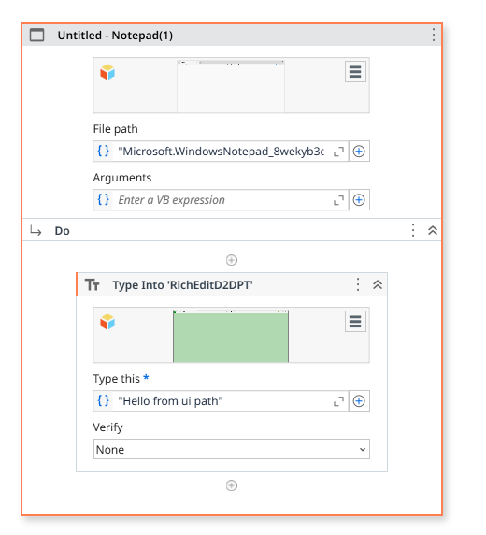

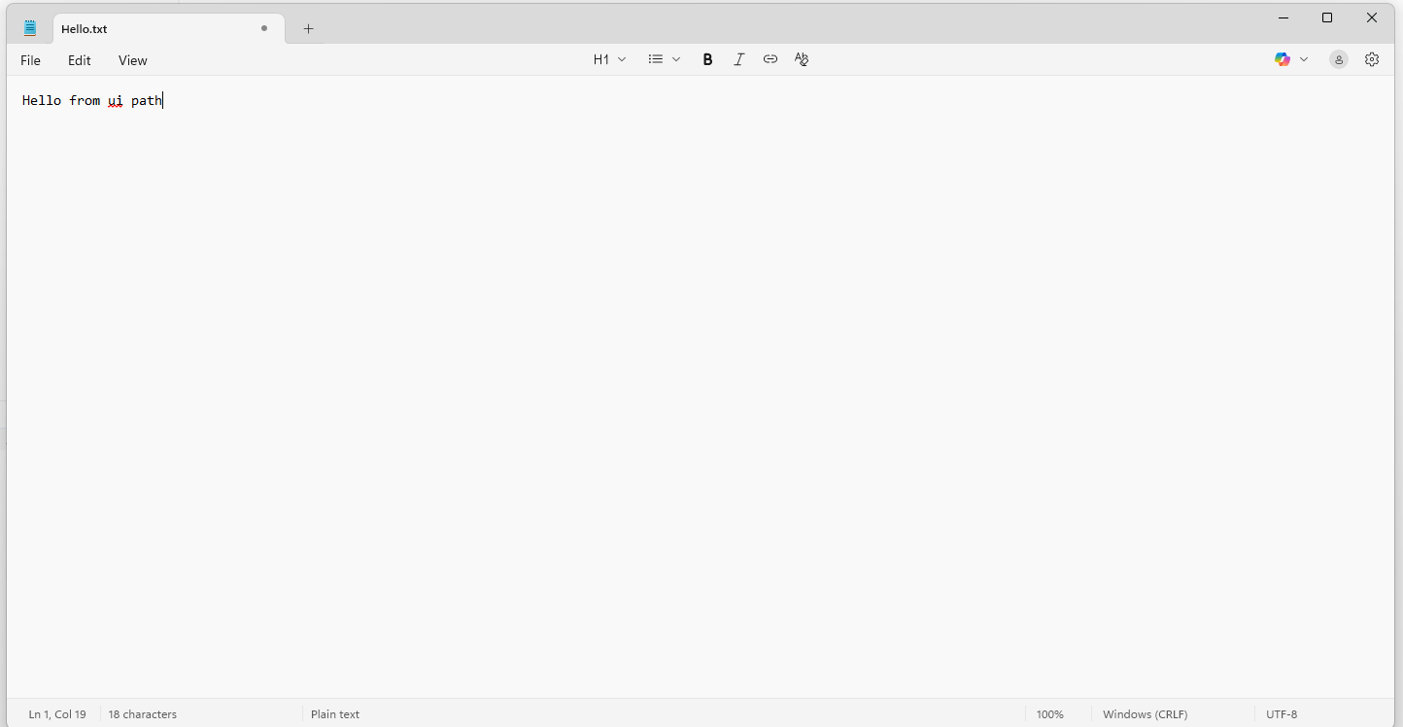

Result
Thus, typing the data in notepad using rpa is completed successfully.

